Program Salt & Smooth
Statslibrary2
Laiba S Khan
2023
Table of Contents
Plot Salt Smooth 2
The Function 2
Program Plotter 3
ProgramPlotter.java was implemented with two methods, one for writing results into a CSV file, and one that calculated the function results. The method ResultsinRange method is as shown below. 3
Salter 5
Smoother 6
Apache and Maven 8
Matlab Octave 10
RSI Calculator 15
Normal Distribution, Gamma, Beta Distribution Essay 17
References 17

Plot Salt Smooth

The Function
The function that was chosen for this assignment was $f\left(x\right)= e + x^{\sin\left(x\right)}$. This equation was chosen due to the way the graph appears, and its higher challenge to implement. The function includes both the eulers number, an exponent, and sin(x).
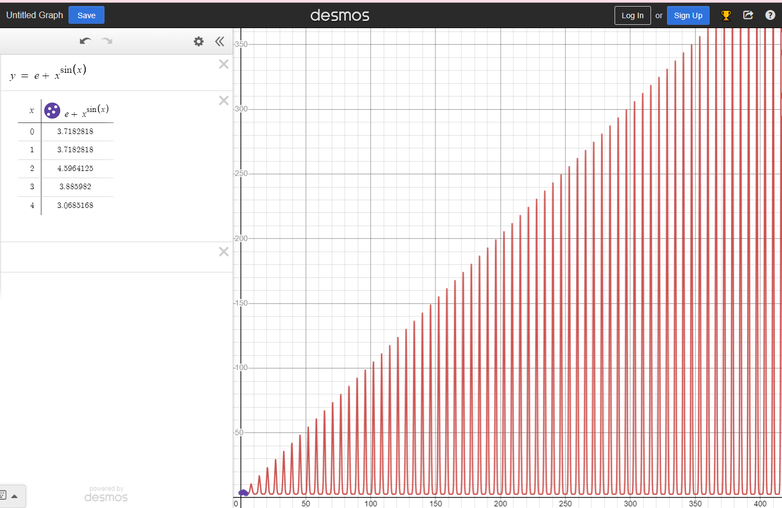

Program Plotter

ProgramPlotter.java was implemented with two methods, one for writing results into a CSV file, and one that calculated the function results. The method ResultsinRange method is as shown below.

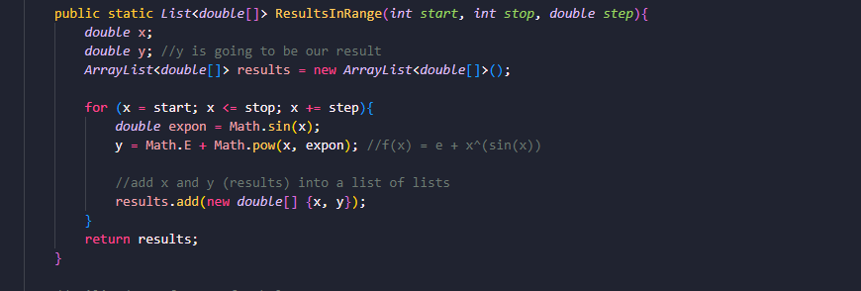
The ResultsinRange method takes the parameters for when you want the x-value to start, stop, and the increments of it as well. It takes each input, calculates the result (which is the corresponding y-value), and adds it to a new ArrayList called results. It returns the list, allowing the CSVWriter to use the list and write a CSV file with your choice of file name.

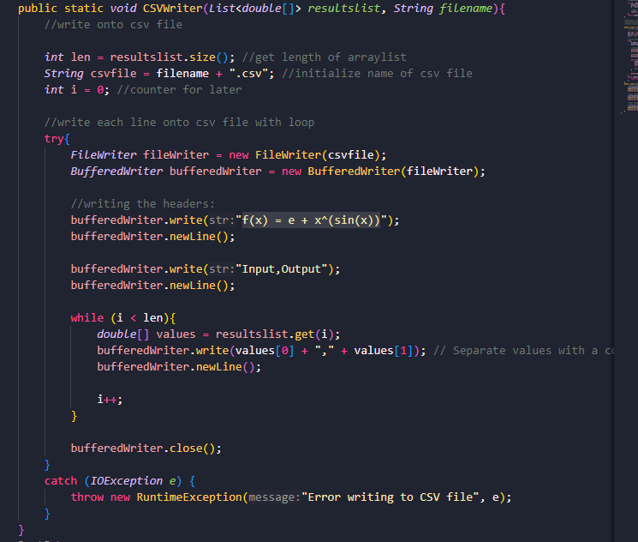
The CSVWriter takes an arraylist (or list within a list), such as what is returned by ResultsinRange, and computes the y value of the equation. It then utilizes FileWriter and BufferedWriter to write the values of x and y as comma separated values. It also writes the headers, one describing the equation, and then input and output labels.
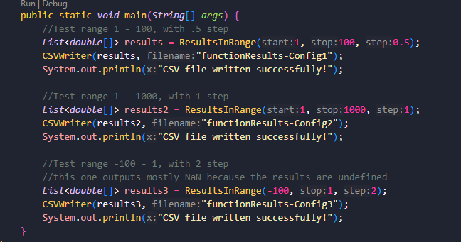
Each test shows different ranges and scenarios. All tests produce results with the correct ranges and steps. Notably, the last one produces a long column of NaN y-values. This is because y is undefined when x < 0.

Salter
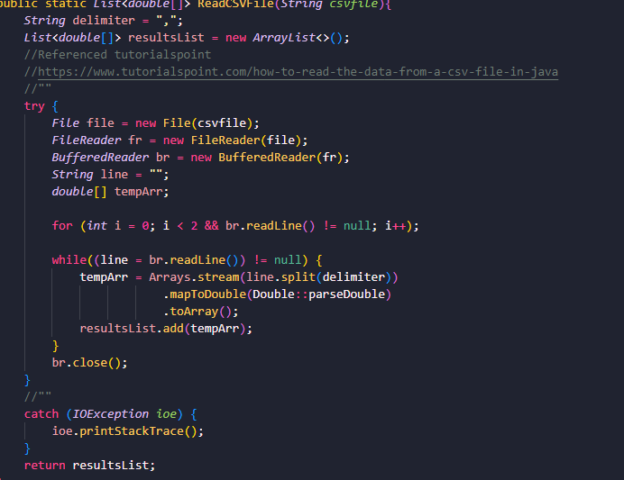
A reference was used for method ReadCSVFile. You can find the link within the code, and at the References page of this report. This method skips the first two lines within the CSV file, which are the headers (as written in the CSVWriter method). This reader is only compatible with CSV files that are formatted as such. It then iterates through the lines and stores them in a temporary array, then the returned list.
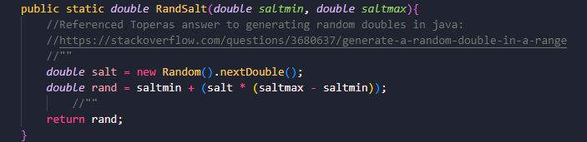
Here is a helper function to generate a random salt value.

Smoother

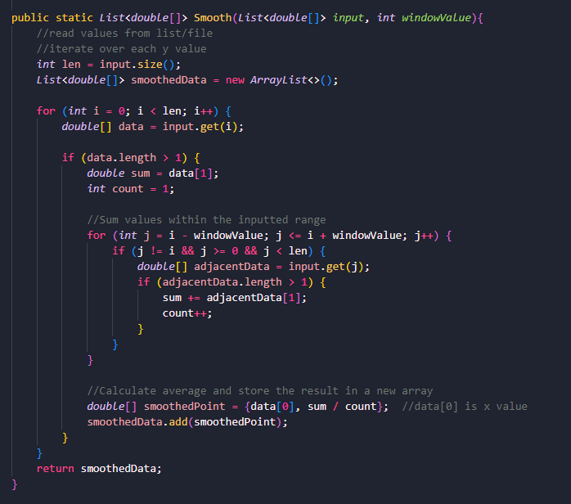

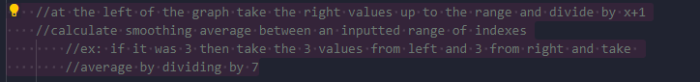

The notes above describe the purpose of this code very sufficiently. It takes the input of a List within a list, and then uses temporary lists to iterate through and take the “moving mean”. This outputs a list that you can then use CSVWriter method in ProgramPlotter.java.
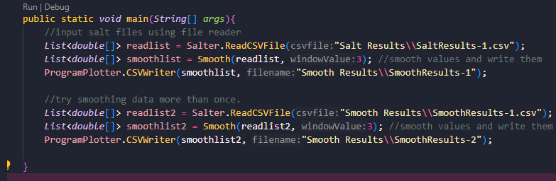
This outputs two tests, which both work sufficiently.

Apache and Maven

Maven and Apache:
https://commons.apache.org/proper/commons-math/userguide/stat.html
Using the StatUtils utility class:
1.2
// Compute statistics directly from the array
// assume values is a double[] array
double mean = StatUtils.mean(values);
double std = FastMath.sqrt(StatUtils.variance(values));
double median = StatUtils.percentile(values, 50);

// Compute the mean of the first three values in the array
mean = StatUtils.mean(values, 0, 3);
You can use this to do the smoothing
Or when using Mav select Create Maven Project after downloading maven extension (if you don’t already have it)


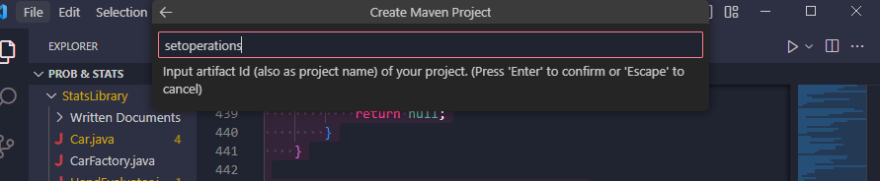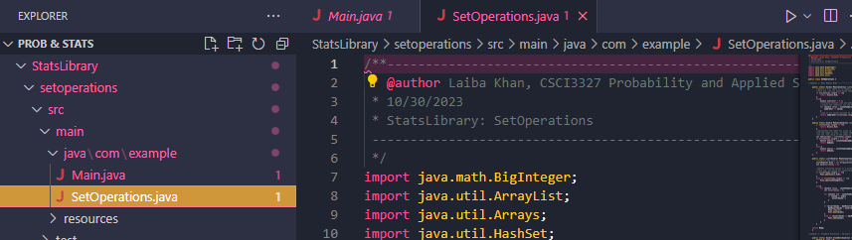
After right clicking maven project and selecting custom command
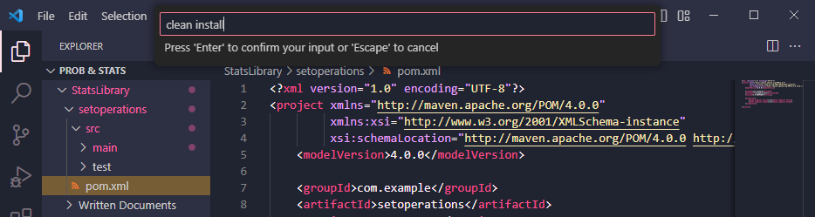

Matlab Octave
Continuing into using Matlab Octave, multiple resources were used as supplemental information. These are listed below.
Tutorials Used:
LINK: |  | USES:
1. | https://www.mathworks.com/help/matlab/ref/plot.html | Do original line plot.
2. | https://www.youtube.com/watch?v=aD8k4pYUBOk | Graph design and plotting.
3. | https://www.mathworks.com/matlabcentral/answers/579033-how-to-add-a-noise-in-my-input-graph | Noise/salt the graph.
4. | https://www.mathworks.com/help/matlab/ref/movmean.html | Smoothing the graph.

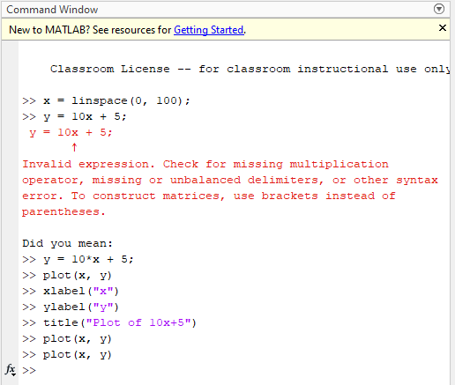
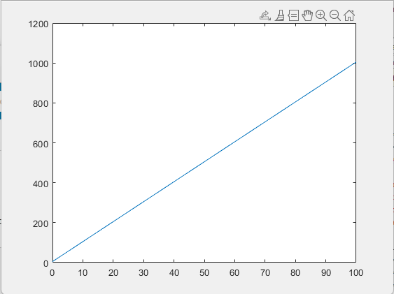
This is the original attempt to plot a line using the first tutorial.

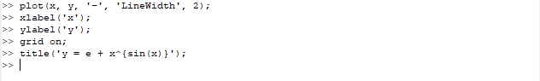
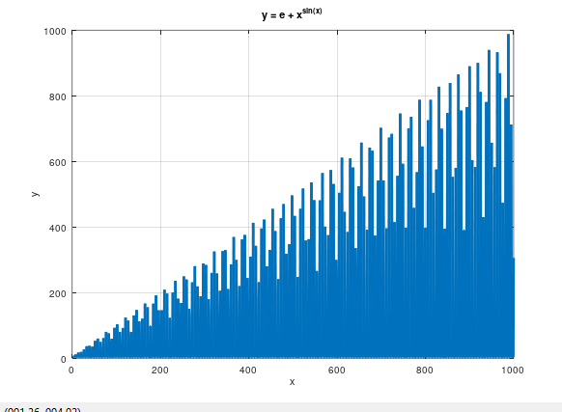
Here is the graph of the original function plotted. This is read from second CSVfile generated by the first ProgramPlotter test (functionResults -config2). I copied and renamed the file in order to use it for this graph.

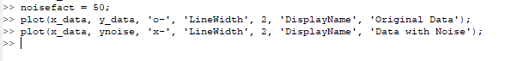
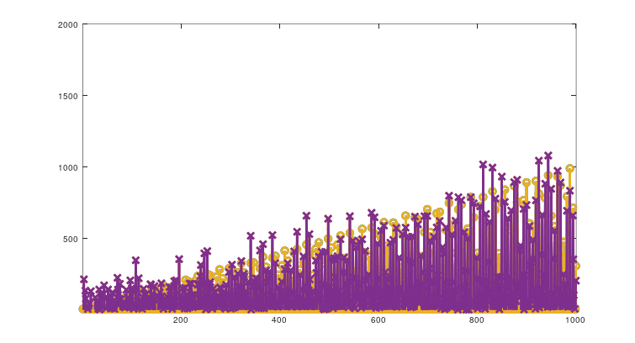
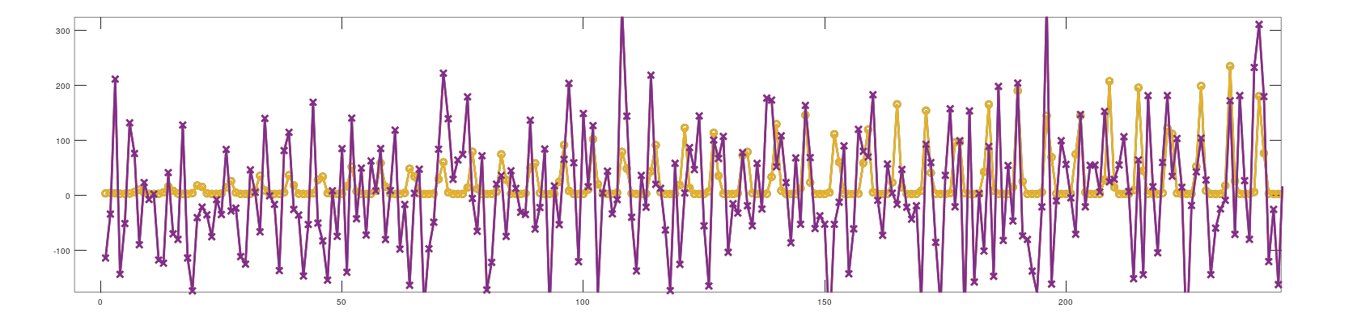
Here the noise is graphed on top of the original plot. In the second picture you can see exactly how salted the graph is. As you can see in the code above, I made the salting/noise factor 50, which you can clearly see in the graph as well. The salted is depicted as the purple line, while the unsalted is the yellow.

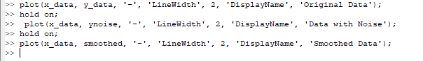
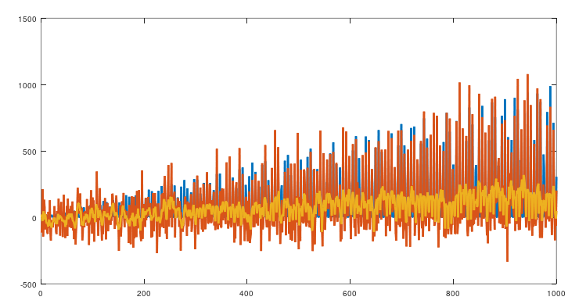
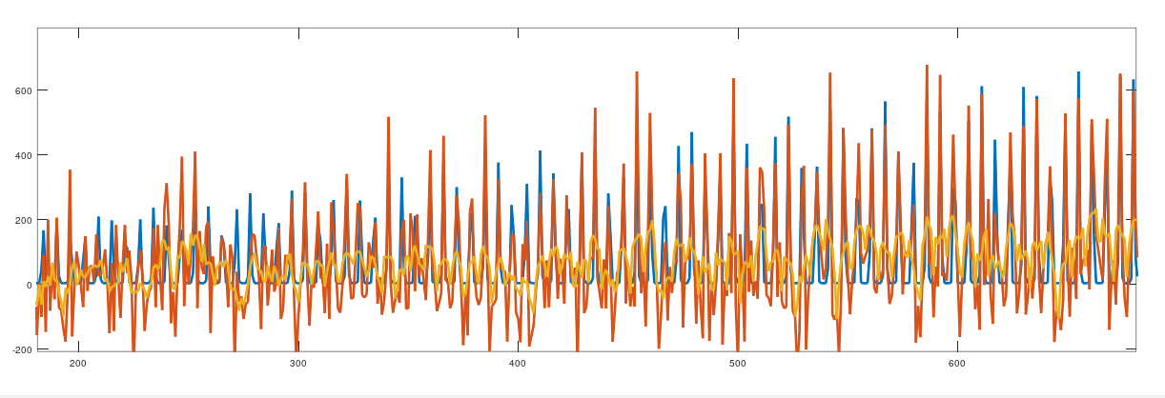
The code and graphs shown above are the final versions of the results. These results show the difference between the Programmed, Salted, and Smoothed plot points and graphs. It also shows how easy and dynamic of a program Matlab Octave is, and how it can be useful when evaluating data.

RSI Calculator
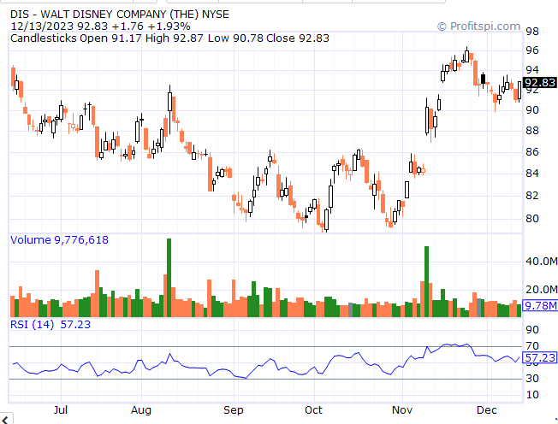
https://finance.yahoo.com/quote/DIS/history/
Above is the screenshotted graph of Walt Disney RSI graph from the previous months. This is to show/estimate the potential results garned from the RSICalculator.java methods and whether or not they are correct.

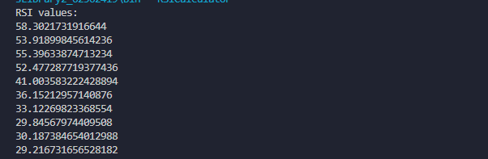
This shows the results printed within the console when testing the calculateRSI method. This prints the last 10 days in the order of newest to oldest, matching their respective inputted days. It shows that the results are about right. They line up the graphs depiction.

Normal Distribution, Gamma, Beta Distribution Essay

The Beta distribution is a continuous probability distribution defined on the interval [0,1][0,1] (Smith, 2007). It is widely used in Bayesian statistics, machine learning, and modeling proportions. T The parameters α and β control the shape of the distribution (Smith, 2007). The Beta distribution is versatile, as it can model a variety of shapes depending on the parameter values. It is often used as a prior distribution in Bayesian analysis.
The Gamma distribution is a family of continuous probability distributions. It is often used to model the waiting time until a Poisson process reaches a certain number of events. Γ(α) is the gamma function. The parameters α and β control the shape and scale of the distribution (Johnson & Kotz, 1970). When α is a positive integer, the Gamma distribution is equivalent to the Erlang distribution.
The Normal distribution, also known as the Gaussian distribution, is a continuous probability distribution that is symmetric and bell-shaped. It is a fundamental distribution in statistics and probability theory. The μ is the mean and σ is the standard deviation. The parameters μ and σ uniquely define the distribution. The Normal distribution is significant due to the Central Limit Theorem, which states that the sum or average of a large number of independent and identically distributed random variables will be approximately normally distributed (Johnson & Kotz, 1970).
In conclusion, the Beta, Gamma, and Normal Distributions are essential tools in probability and statistics, each with its unique characteristics and applications. Understanding these distributions is crucial for modeling real-world phenomena, making statistical inferences, and conducting hypothesis testing.

References

Smith, A. (2007). Introduction to the Beta Distribution and Bayesian Inference (Working Paper). Retrieved from https://bookdown.org/probability/beta/beta-and-gamma.html
Johnson, N. L., & Kotz, S. (1970). Continuous Univariate Distributions - 1 (2nd ed.). Houghton Mifflin.

